Ex: 3 MIN-MAX ALGORITHM

Aim: To implement Minimax algorithm for game playing (Alpha-Beta pruning)

Description
Suppose we have a binary tree representing a game state of a two player game. Every internal node is filled with 0 and the leaves values represent the end score. Player 1 wants to maximize the end score while player 2 wants to minimize the end score. Player 1 will always make moves on nodes at even levels and player 2 will always make moves on odd levels. We have to fill in the binary tree with the resulting scores assuming both of players play optimally. So, if the input is like

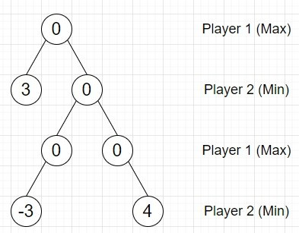

Algorithm
- Define a function helper() . This will take root, h, currentHeight
- if root is empty, then
  - return
- helper(left of root, h, currentHeight + 1)
- helper(right of root, h, currentHeight + 1)
- if currentHeight < h, then
  - if currentHeight is even, then
    - if left of root and right of root are not null, then
      - value of root := maximum of value of left of root, value of right of root
    - otherwise when left of root is not null, then
      - value of root := value of left of root
    - otherwise when right of root is not null, then
      - value of root := value of right of root
  - otherwise,
    - if left of root and right of root are not null, then
      - value of root := minimum of value of left of root, value of right of root
    - otherwise when left of root is not null, then
      - value of root := value of left of root
    - otherwise when right of root is not null, then
      - value of root := value of right of root
- Define a function height() . This will take root
- if root is null, then
  - return 0
- return 1 + (maximum of height(left of root) , height(right of root))
- From the main method, do the following −
- h := height(root)
- helper(root, h, 0)
- return root

PROGRAM

class TreeNode:
def __init__(self, data, left=None, right=None):
self.val = data
self.left = left
self.right = right

class Solution:
def helper(self, root, h, currentHeight):
if not root:
return
self.helper(root.left, h, currentHeight + 1)
self.helper(root.right, h, currentHeight + 1)
if currentHeight < h:
if currentHeight % 2 == 0: # Even level
if root.left and root.right:
root.val = max(root.left.val, root.right.val)
elif root.left:
root.val = root.left.val
elif root.right:
root.val = root.right.val
else: # Odd level
if root.left and root.right:
root.val = min(root.left.val, root.right.val)
elif root.left:
root.val = root.left.val
elif root.right:
root.val = root.right.val

def height(self, root):
if not root:
return 0
return 1 + max(self.height(root.left), self.height(root.right))

def solve(self, root):

h = self.height(root)
self.helper(root, h, 0)
return root

def print_tree(root):
if root is not None:
print_tree(root.left)
print(root.val, end=', ')
print_tree(root.right)

ob = Solution()
root = TreeNode(0)
root.left = TreeNode(3)
root.right = TreeNode(0)
root.right.left = TreeNode(0)
root.right.right = TreeNode(0)
root.right.left.left = TreeNode(-3)
root.right.right.right = TreeNode(4)

print_tree(ob.solve(root))

Output
3, 3, -3, -3, -3, 4, 4,

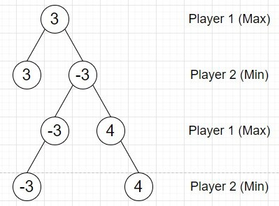

Result : Thus the MinMax algorithm is implemented using python

Ex: 4 CONSTRAINT SATISFACTION PROGRAM

Aim: To solve constraint satisfaction problem using python.

Description:
Constraint programming is an example of the declarative programming paradigm, as opposed to the usual imperative paradigm that we use most of the time. Most programming paradigms can be classified as a member of either the imperative or declarative paradigm group.

Imperative programming, simply put, is based on the developer describing the solution/algorithm for achieving a goal (some kind of result). This happens by changing the program state through assignment statements, while executing instructions step-by-step. Therefore it makes a huge difference in what order the instructions are written.

Declarative programming does the opposite - we don't write the steps on how to achieve a goal, we describe the goal, and the computer gives us a solution. A common example you should be familiar with is SQL. Do you tell the computer how to give you the results you need? No, you describe what you need - you need the values from some column, from some table, where some conditions are met.

Procedure
Installing the python-constraint Module
In this procedure we'll be working with a module called python-constraint (Note: there's a module called "constraint" for Python, that is not what we want), which aims to bring the constraint programming idea to Python.

To install this module, open the terminal and run:

$ pip install python-constraint Basics of Using python-constraint
This is the generalized skeleton of programs written using this module (Note: we use import constraint and not import python-constraint)
- import constraint
- define a variable as our problem

- add variables and their respective intervals to our problem
- add built-in/custom constraints to our problem
- fetch the solutions
- go through the solutions to find the ones we need

As previously mentioned, constraint programming is a form of declarative programming. The order of statements doesn't matter, as long as everything is there in the end. It's usually used to solve problems like this:

Example A
Find all (x,y) where x ∈ {1,2,3} and 0 <= y < 10, and x + y >= 5
If we look at this sentence, we can see several conditions (let's call them constraints) that x and y have to meet.

For example, x is "constrained" to the values 1,2,3, y has to be less than 10 and their sum has to be greater than or equal to 5. This is done in a few lines of code and in a few minutes using constraint programming.

Looking at the problem above you probably thought "So what? I can do this with 2 for loops and half a cup of coffee in Python in less than 10 minutes".

You're absolutely right, though through this example we can get an idea of what constraint programming looks like:

PROGRAM

import constraints

problem = constraint.Problem()

# Define variables and their domains
problem.addVariables("TF", range(1, 10)) # T, F (1-9)
problem.addVariables("WOUR", range(10)) # W, O, U, R (0-9)

# Define the sum constraint
def sum_constraint(t, w, o, f, u, r):
return 2 * (t * 100 + w * 10 + o) == f * 1000 + o * 100 + u * 10 + r

# Add the sum constraint to the problem
problem.addConstraint(sum_constraint, "TWOFUR")

# Add the AllDifferentConstraint to ensure unique digits
problem.addConstraint(constraint.AllDifferentConstraint())

# Solve the problem and print results
solutions = problem.getSolutions()
print("Number of solutions found: {}\n".format(len(solutions)))

# Print the first solution
for s in solutions:
print("T = {}, W = {}, O = {}, F = {}, U = {}, R = {}".format(
s['T'], s['W'], s['O'], s['F'], s['U'], s['R']))
Break

Output
Number of solutions found: 7
T = 7, W = 6, O = 5, F = 1, U = 3, R = 0
T = 7, W = 3, O = 4, F = 1, U = 6, R = 8
T = 8, W = 6, O = 7, F = 1, U = 3, R = 4
T = 8, W = 4, O = 6, F = 1, U = 9, R = 2
T = 8, W = 3, O = 6, F = 1, U = 7, R = 2
T = 9, W = 2, O = 8, F = 1, U = 5, R = 6
T = 9, W = 3, O = 8, F = 1, U = 7, R = 6

Result : Thus the constraint satisfaction problem is resolved successfully.

